**USER MANUAL**

# Introduction

Sydney Airbnb Database Analysis is a simple data analysis and visualization tool built for not only local and international tourists visiting Sydney but also for local businesses and individuals who run Airbnb properties in Sydney to manage their business better. Based on a well-known source InsideAirbnb, a dataset collecting detailed listing activity of homestays in Sydney from end of 2018 to end of 2019 will be used to help implementing the software, thus finding out some valuable insights for tourist.

# Getting Started

This software is a Python-based interactive web application by converting Excel Files and doing some data exploration using the Python Library Streamlit. It simplifies the process of creating data-driven applications by providing a straightforward and intuitive interface. Thus, before you can use this web app, Python app and Streamlit library need to be installed in order to run the server. All the necessary excel and python files can be downloaded from the following GitHub repository.

( <https://github.com/Alice25092003/2810ICT_Assignment_Group55.git> )

To run our web app, you need to open a command prompt or terminal window, navigate to the app’s directory and run the path leading to Homepage.py file with Streamlit as below:

The software will then begin running, and you can access it by opening your web browser and navigating to <http://localhost:8501>. As the size of the original excel files are more than 500MB in total, it takes time for the application to load and display the data.

# User Interface

## Homepage

The homepage site is the landing page of our web app. It provides an overview of the original dataset where you can examine and look up every single feature and value of all the recorded AirBnB properties between 12/2018-12/2019:

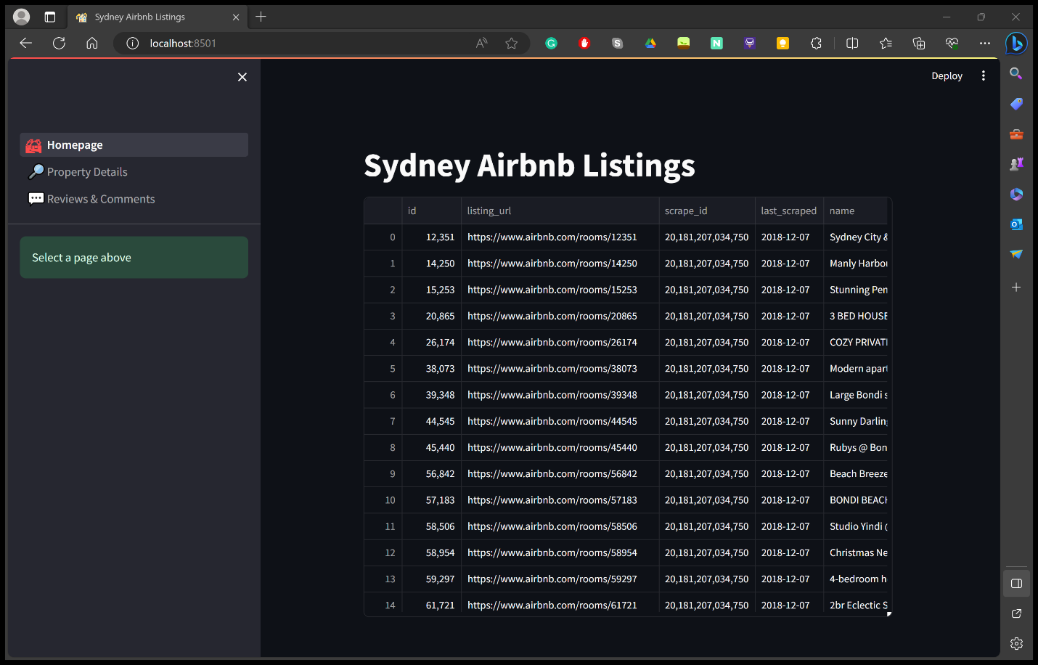

On the left side of the screen, there is sidebar menu where you can navigate and access 2 main features and settings of the applications: Property Details and Reviews & Comments.

## Property Details

The Property Details screen is a powerful feature that allows users to find a list of property information based on their preferences. With options to filter by time period from 12/2018 to 12/2019 , available suburb locations in Sydney and desired description keyword, users can refine their search and make informed decisions. The user-selected period is required to be given in order to run the analysis, while other features are optional. With the selected period given, a price distribution of all the properties available during the period will also be displayed as well. If no period is selected, the system will not return the data.

## Reviews & Comments

The Reviews & Comments site is a special resource for individuals who are interested in knowing more about a particular property’s reputation and the experiences of other customers who have used the service. By entering a Property ID based on the previous dataset, users can access to a wealth of information, specifically review scores and comments regarding the cleanliness of the property provided by previous tenants and visitors. It is important for the users to specify the correct Property ID that is available in the database, or else the system cannot return the dataset.

